**National Aeromodelling Competition Abstract**

**Team Name : Desert Hawks**

**Team Members: 1. Mohit Deharkar**

**2. Taksh Mehta**

**3. Parv Dixit**

**4. Rishu Kumar**

**Team representative’s e-mail ID:b24ch1023@iitj.ac.in**

**Design Overview**

* Our model aircraft design draws inspiration from the Cessna 150, known for its simple yet effective fixed-wing structure. The goal is to create a lightweight and efficient plane that meets the competition's payload and weight constraints while maintaining stability and performance. The design incorporates innovative features such as payload management and center of gravity (CG) adjustment, ensuring smooth operations.

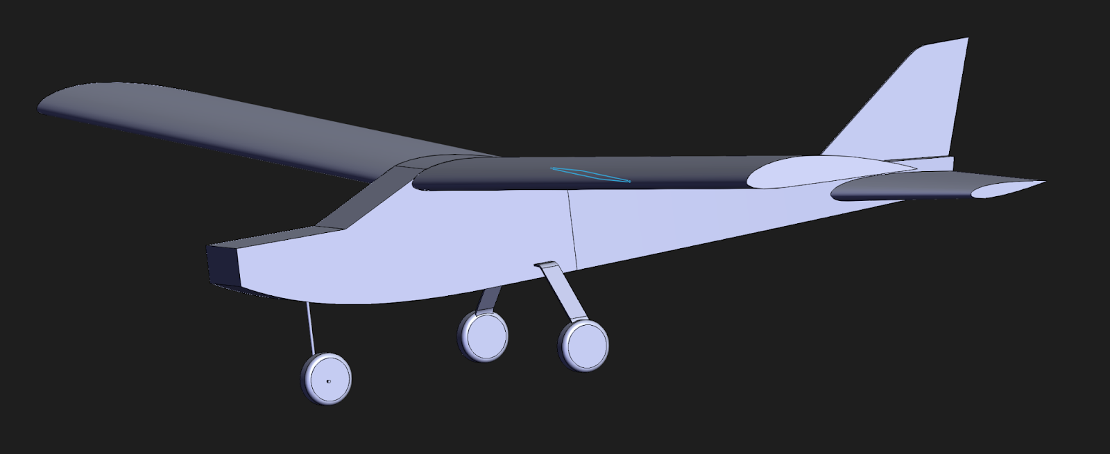

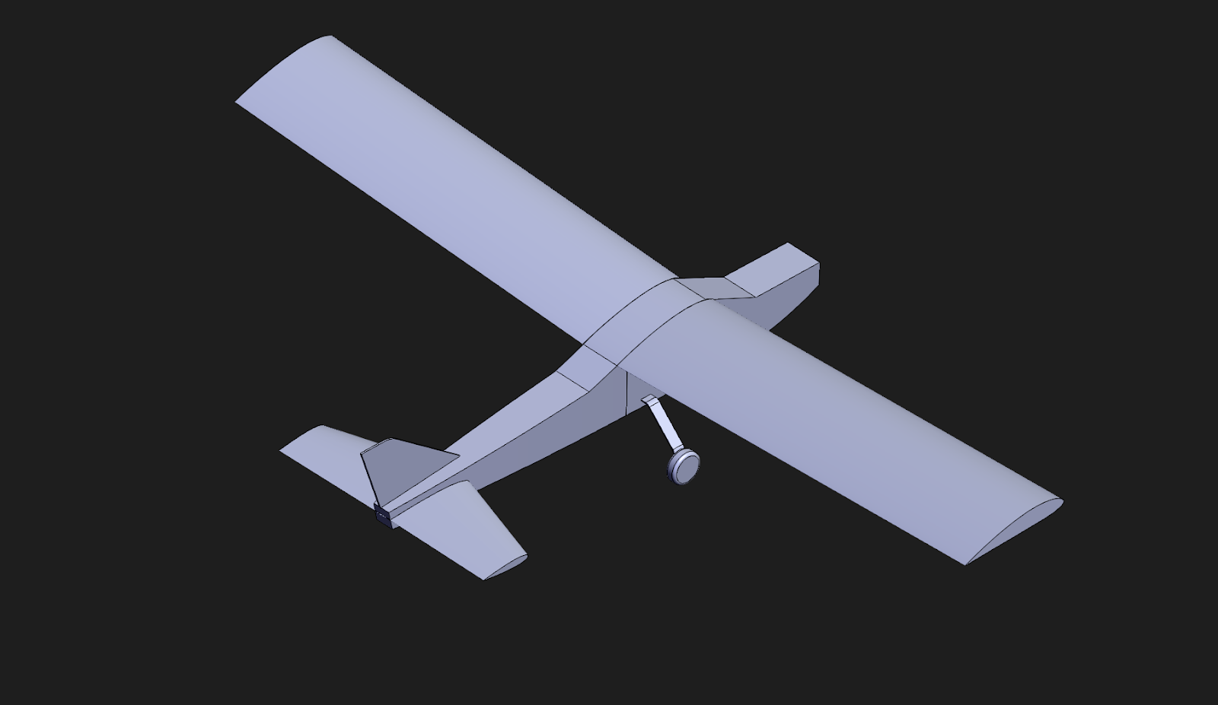

**Design Features**

**Propulsion System**

* The aircraft uses a 1500-kilowatt brushless DC motor paired with a 3S LiPo battery.
* The motor generates a thrust of 700-750 grams, achieving a thrust-to-weight ratio of less than 1, which is sufficient for efficient flight and payload handling.

**Wing Design**

* The wingspan-to-width ratio is 1.47:1, (usually a ratio between 1.35 - 2.10 is considered good for smooth gliding)

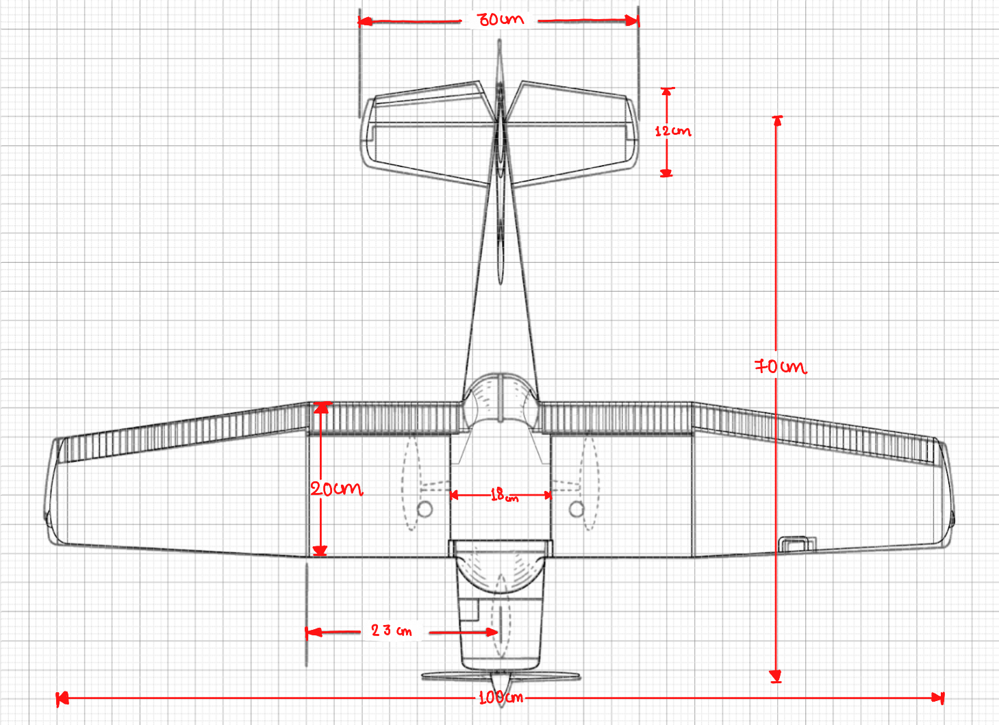

**Airframe Construction**

* The body is constructed using thermocol, a lightweight yet durable material. This reduces the total weight while maintaining structural integrity.
* The estimated body weight : 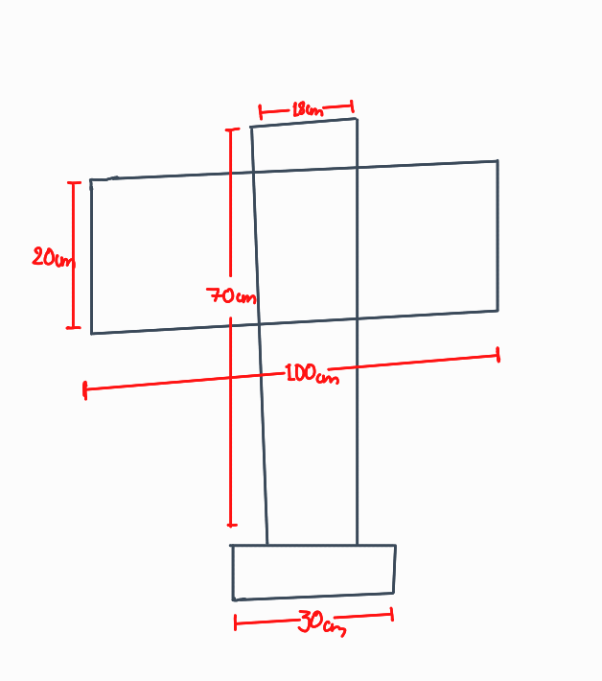

If we consider the parts of the plane as cuboids,with the assumed thermocol density=10 kg/m³ then the weight approximates to:-

100x2.5x18 + 70x18x20 + 12x30x2.5 = 30600 cm³

= 0.306 kg ≈ 300 gm

* Now, the components :

1500kV BLDC 70gm

ESC 30gm

Receiver 50gm

3s Li-po 175gm

5x Servo 9x5 =45gm

Total 370 gm

* Now the airframe and components together weigh around 670 gms
* Adding the payload (4x45 = 180gm) would sum up to 850 gms which is below the 1 kg constraint
* Also the motor with 1045 prop produces around 700 gms of thrust and still the T/W < 1 constraint is maintained

**Payload System**

* A plexiglass payload bay, located in the fuselage behind the wingspan, is controlled by a servo-operated sliding mechanism.
* The bay is designed to hold four G-balls weighing a total of 180 grams, ensuring secure and smooth deployment as the balls will not move and will not disturb the plane’s motion.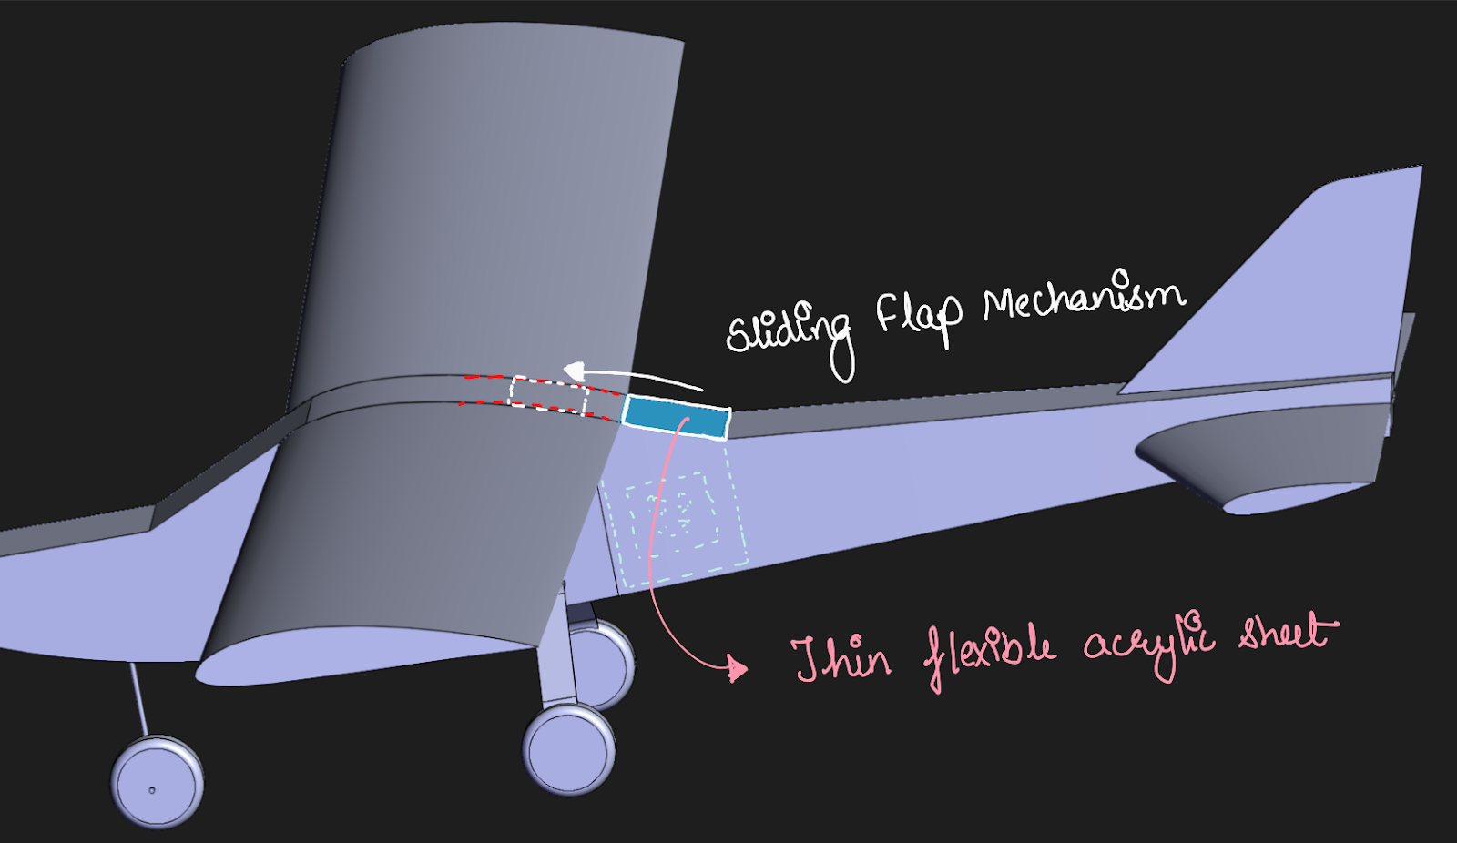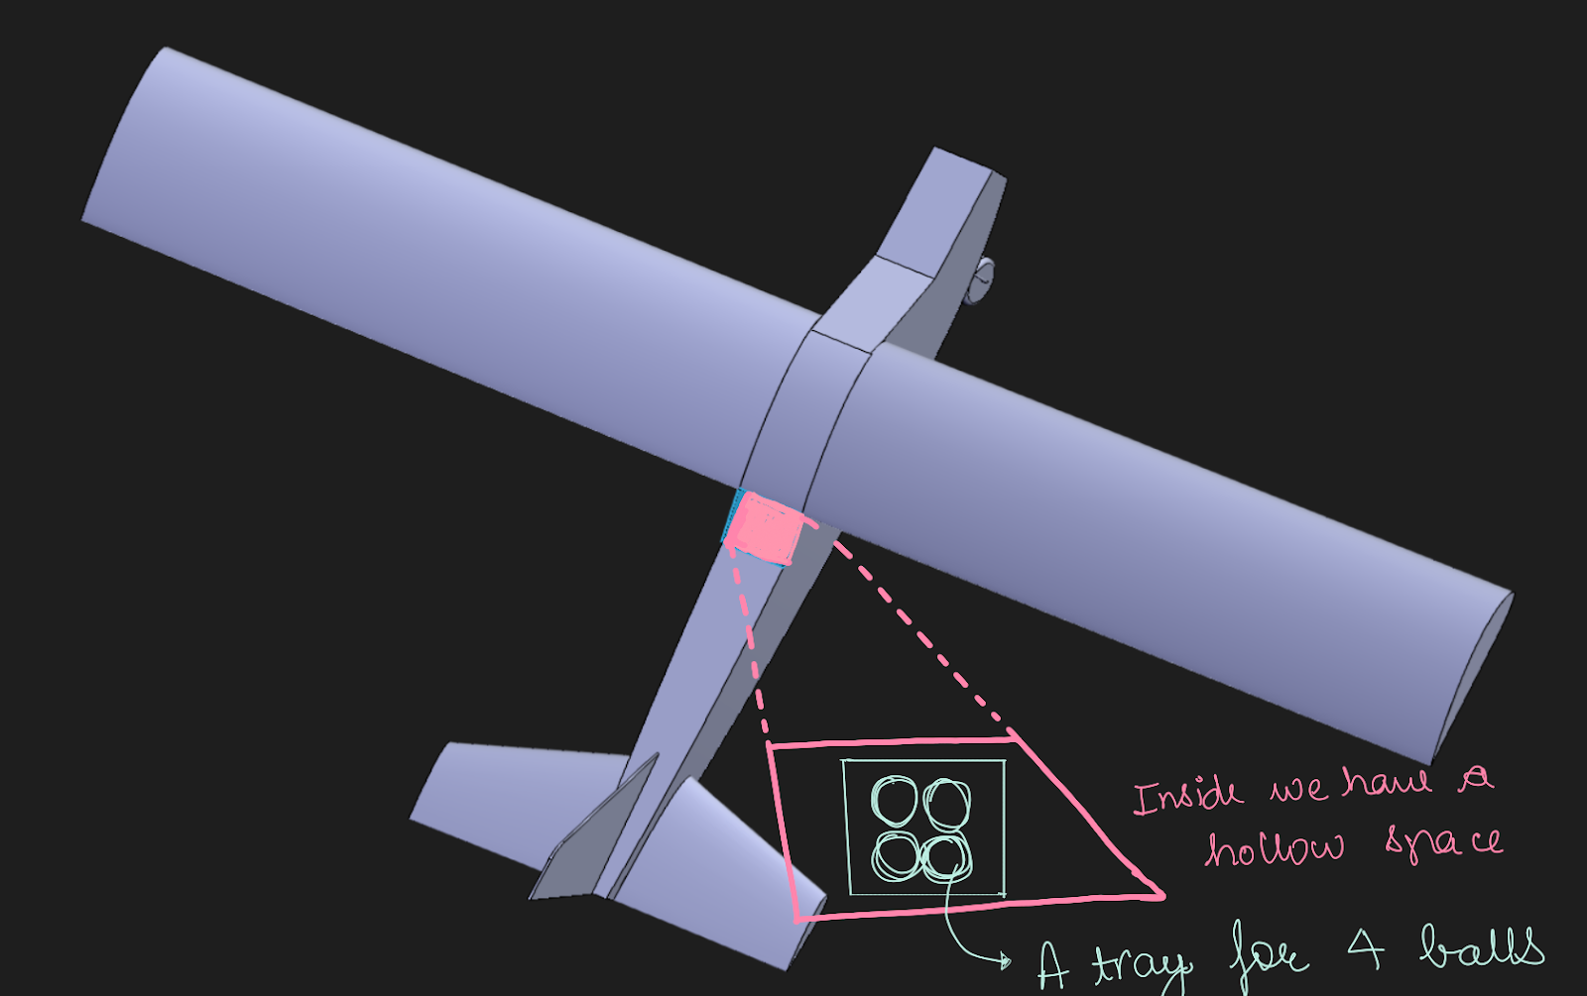

**Stability and Balance**

* Since we would be adding a payload in the competition we want to make sure the balance does not get disturbed due to the payload Hence, to balance the CG, we are adding a sliding battery tray. A sliding battery tray allows dynamic adjustment of the CG to counteract the weight shift caused by the payload.

